Easy CD Creator 4

Creating an Audio CD

Welcome to Easy CD Creator for making your own Audio CD. In this segment we will be selecting Audio files to create a CD. If you want to copy the entire CD, you would select CD copier button. (figure 1)
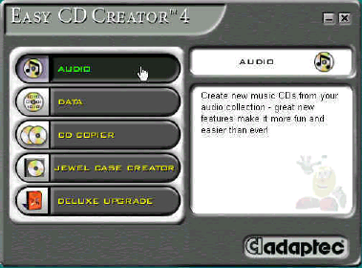
(figure 1)
Click on the Audio CD button to move on. (figure 2)
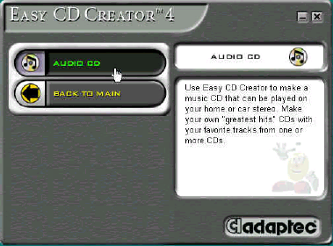
(figure 2)
In the Explorer window, select the D-drive to find the Audio files (tracks).
- Note: Sound files can be found in other Drives. The D-drive was chosen for this example. (figure 3)

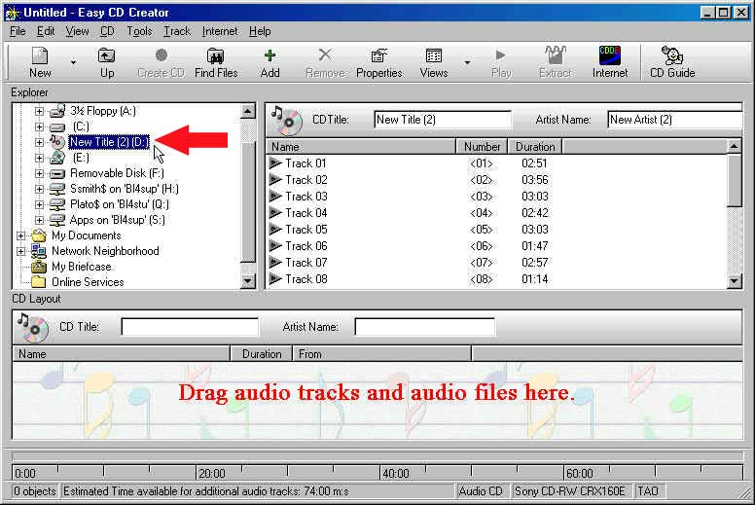
(figure 3)

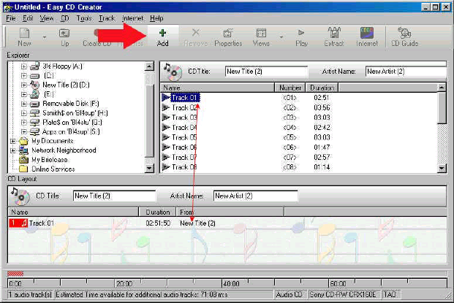When selecting files you can left Click and drag or Click and select a file (or files) and use the Add button. (figure 4)
(figure 4)
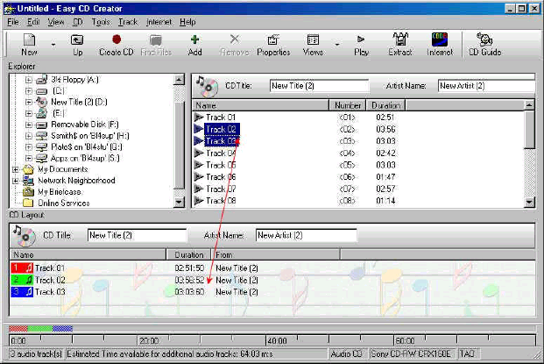
To select more than one file click and use the shift key. Then drag and drop into the CD layout area. Use Control key to select multiple files that are not listed together. (figure 5)
(figure 5)

Under the CD Layout, in the CD title, create the name of title and the artist name.
Next click the Create CD button. (figure 6)

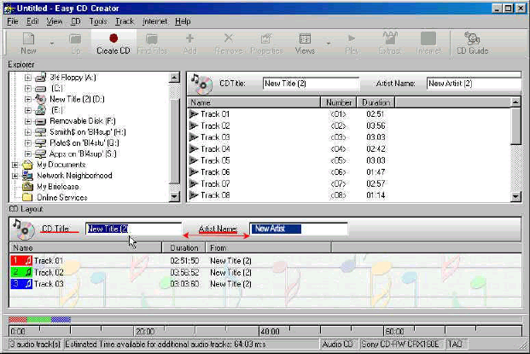
(figure 6)

When creating an Audio CD you only have two speeds that you can use. 2x is recomended for the best quality and 4x is the fastest speed that you can use.
- Note: 650 MB CD equals 74 minutes, so at a writing speed of 2x it would take 37 minutes to burn a CD.
- 4x speed would write a 74 minute CD in 18 minutes.
- There are some burners that will create Audio CD’s faster, but we are using the standard.
Under the Write Method, click on the Disc-At-Once. Disc-at-once recording is the safest recording method, since the entire disc is written in one uninterrupted operation. Lead-in is recorded first, then the program area, and finally lead-out. Data flow to the write laser is continuous, and opportunities for errors are minimized. This selection also closes the disc so that CD players will be able to read the disc. (If the disc is not closed CD players will not recongnize the tracks to play them, only a writable CD Rom in a computer will read it until closed). (figure 7)
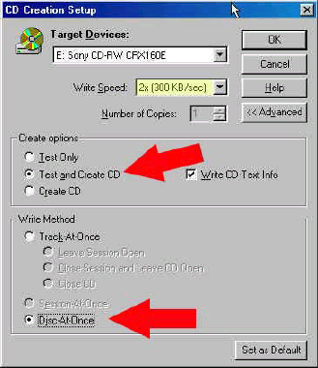
(figure 7)

The testing will take as long as the recording time. (figure 8)

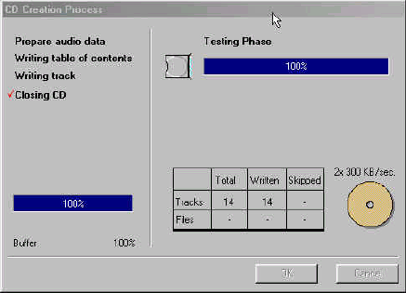
(figure 8)

Final window, only 30 some minutes to go! (figure 9)

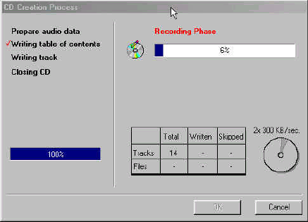
(figure 9)

Another CD Created!!

