Adaptec Easy Creator 4

Creating a Data CD

When you start Adaptec Easy Creator, this is the first window that you will see. You now need to make a choice between the selections below. (figure 1)
- <div align=”left”>We’ll start with Data.</div>

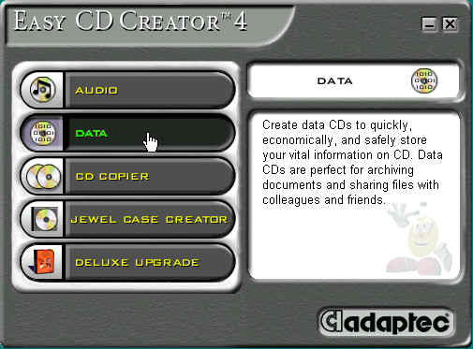

(figure 1)

Choose DIRECTCD or DATA CD, in this case I'm using DATA CD. Use DIRECTCD to drag and drop files onto your CD. This allows you to easily use your CD-Recorder just like a hard disk. Note: You can drag and drop files using Data CD also. (figure 2)

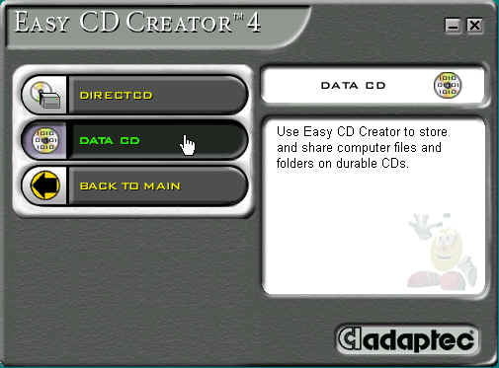

(figure 2)

In the Explorer window after selecting the C-Drive, folders that are located in the C Drive are listed on the right. (figure 3)

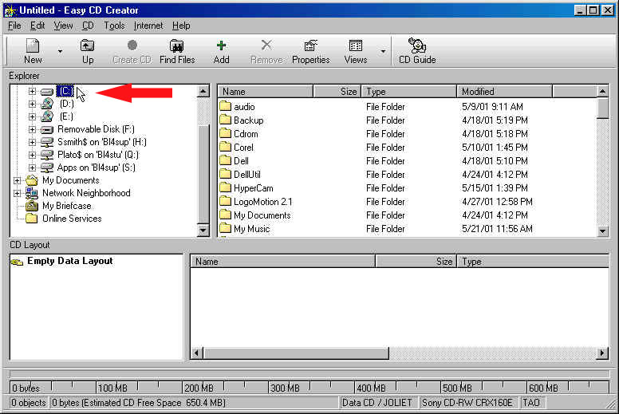

(figure 3)

Selecting My Documents Folder. (figure 4)

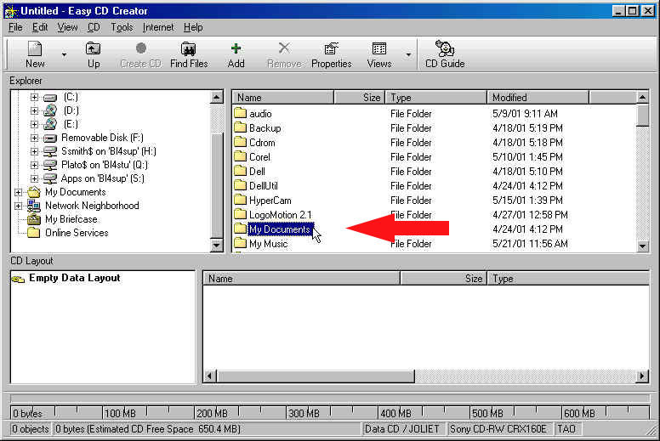
(figure 4)

Inside My Documents folder choose the photoWow5.5 folder. (figure 5)

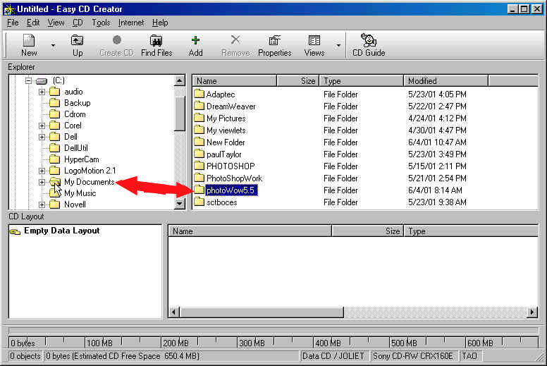
(figure 5)

Select the Wow Teaching G.. Simply drag and drop (left click and drag) into the CD layout area below and release the left click. (figure 6)

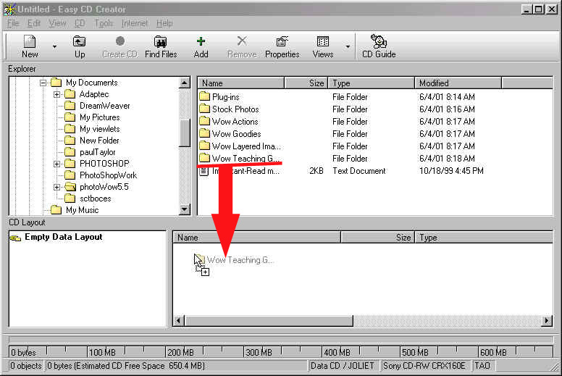
(figure 6)

You can also Left click on the folder you would like to select and click on the add button instead of dragging ands dropping into the CD selected window. There are always numerous ways to achieve the same goal. (figure 7)

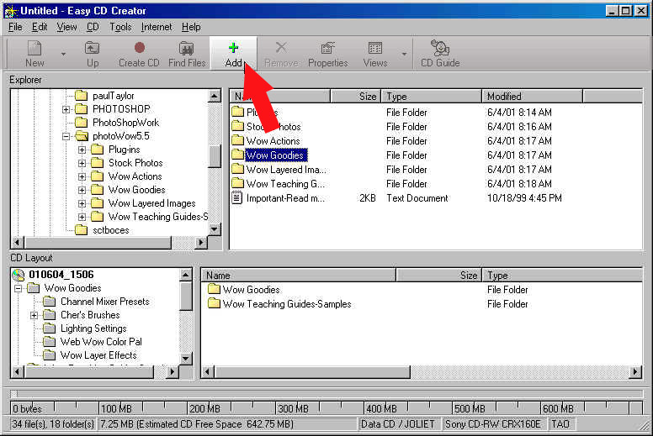

(figure 7)

Once you have selected all the folders and files that you would like to add to your CD, click on the Create CD button to start the recording process.

The first window that pops up in the recording process will show the Target Devices (in my case I only have one recordable device). Next is the Writing speed, you can see from the drop down menu below I have chosen to use the faster of the speeds available with my recorder (12x). (figure 9)

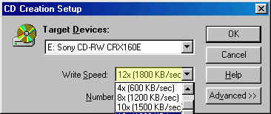  (figure 9) | Note: When recording a Data CD you can use the fastest speed available on your CD ROM Writer. On this Writer we can record at a speed of 12x, which means a 74 minute CD will take 6 minutes to create.  How do you figure how long it takes to write to a disc?  - Divide the number of minutes of the CD into the write speed.  - Example 12x/74=6.1 minutes to write to entire CD.

Click on the advanced button and there are more options to choose from. In the Create options, select Test and Create CD . By testing the files, folders, or CD's that you are copying, Adaptec will let you know if any of the information that you are copying will be complete. In the Write Method choose Track-At-Once and Close Session and Leave CD Open. This allows you to add more data to this CD later. If you are creating an Audio CD or a Data CD for older machines ('95) you will have to Close the CD. Some of the original CD ROM’s may not read any CD that has been recorded. (figure 10)

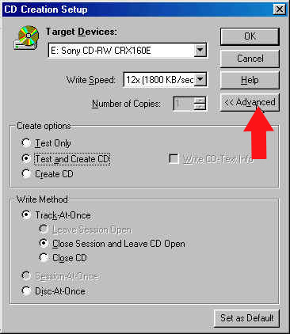(figure 10)

If your adding to a CD-R which has been recorded on but is not full, this is the message that will come up. Click yes! to record new info onto your disc.
(figure 11)

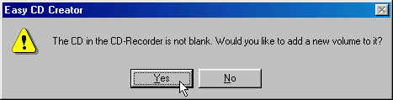(figure 11)

Remember that we selected Test and Record, so the testing window will appear first. When the testing is completed a new window will appear.
(figure 12)
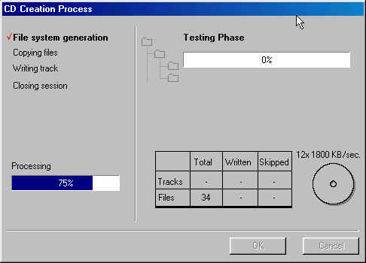
(figure 12)

The recording window will let you know when it is complete. Click OK and your disc will eject. You have now created your own disc. (figure 13)

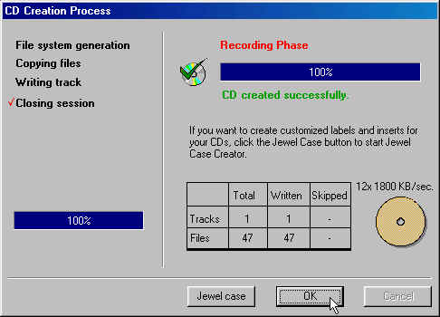(figure 13)

</div>

